**Task 1: Complete the Dockerfile**

**Hadolint Dockerfile**

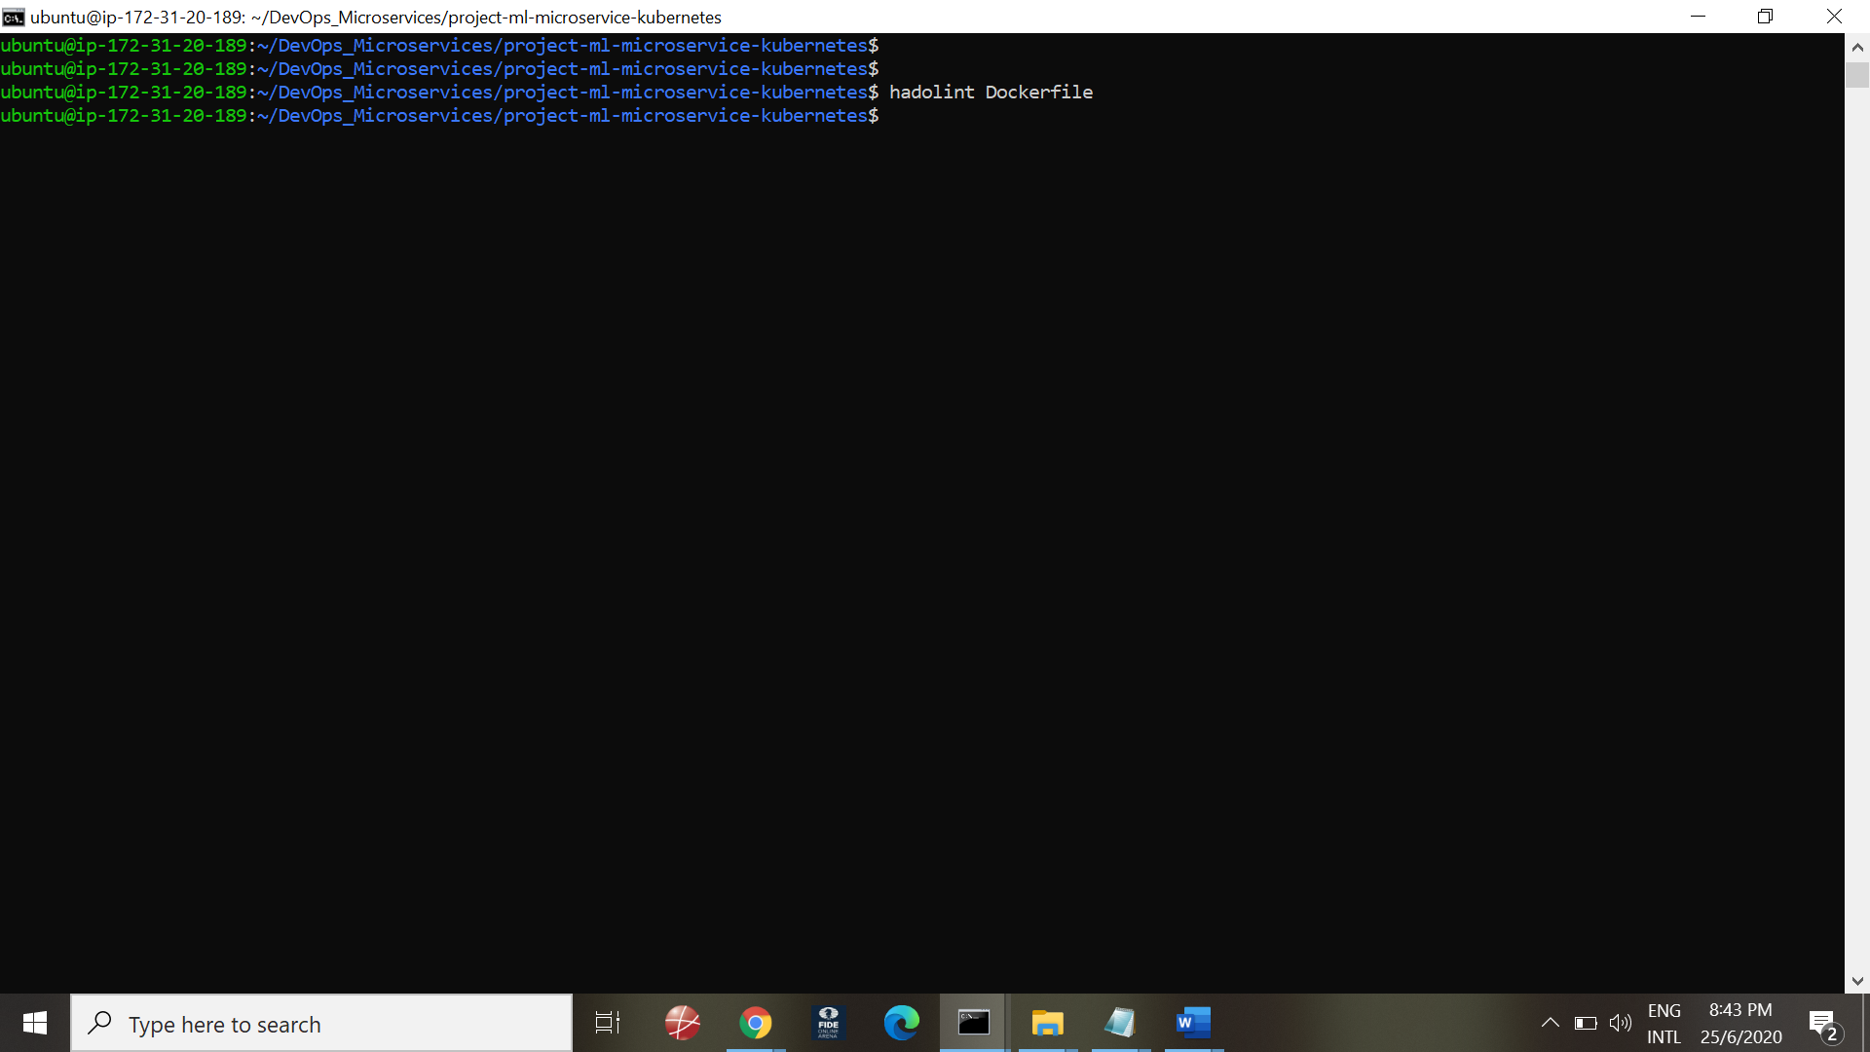

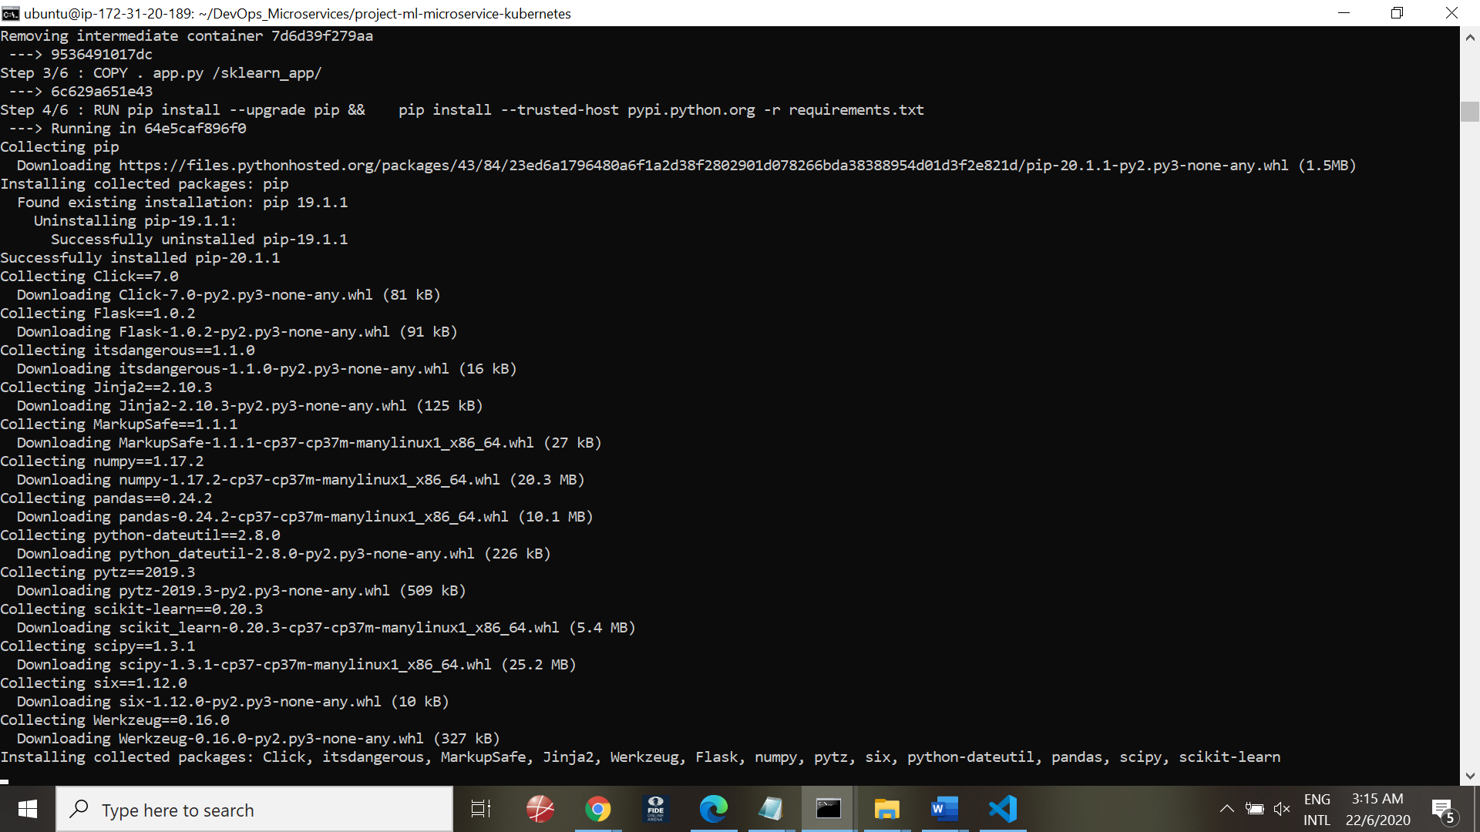

Running the Docker server:

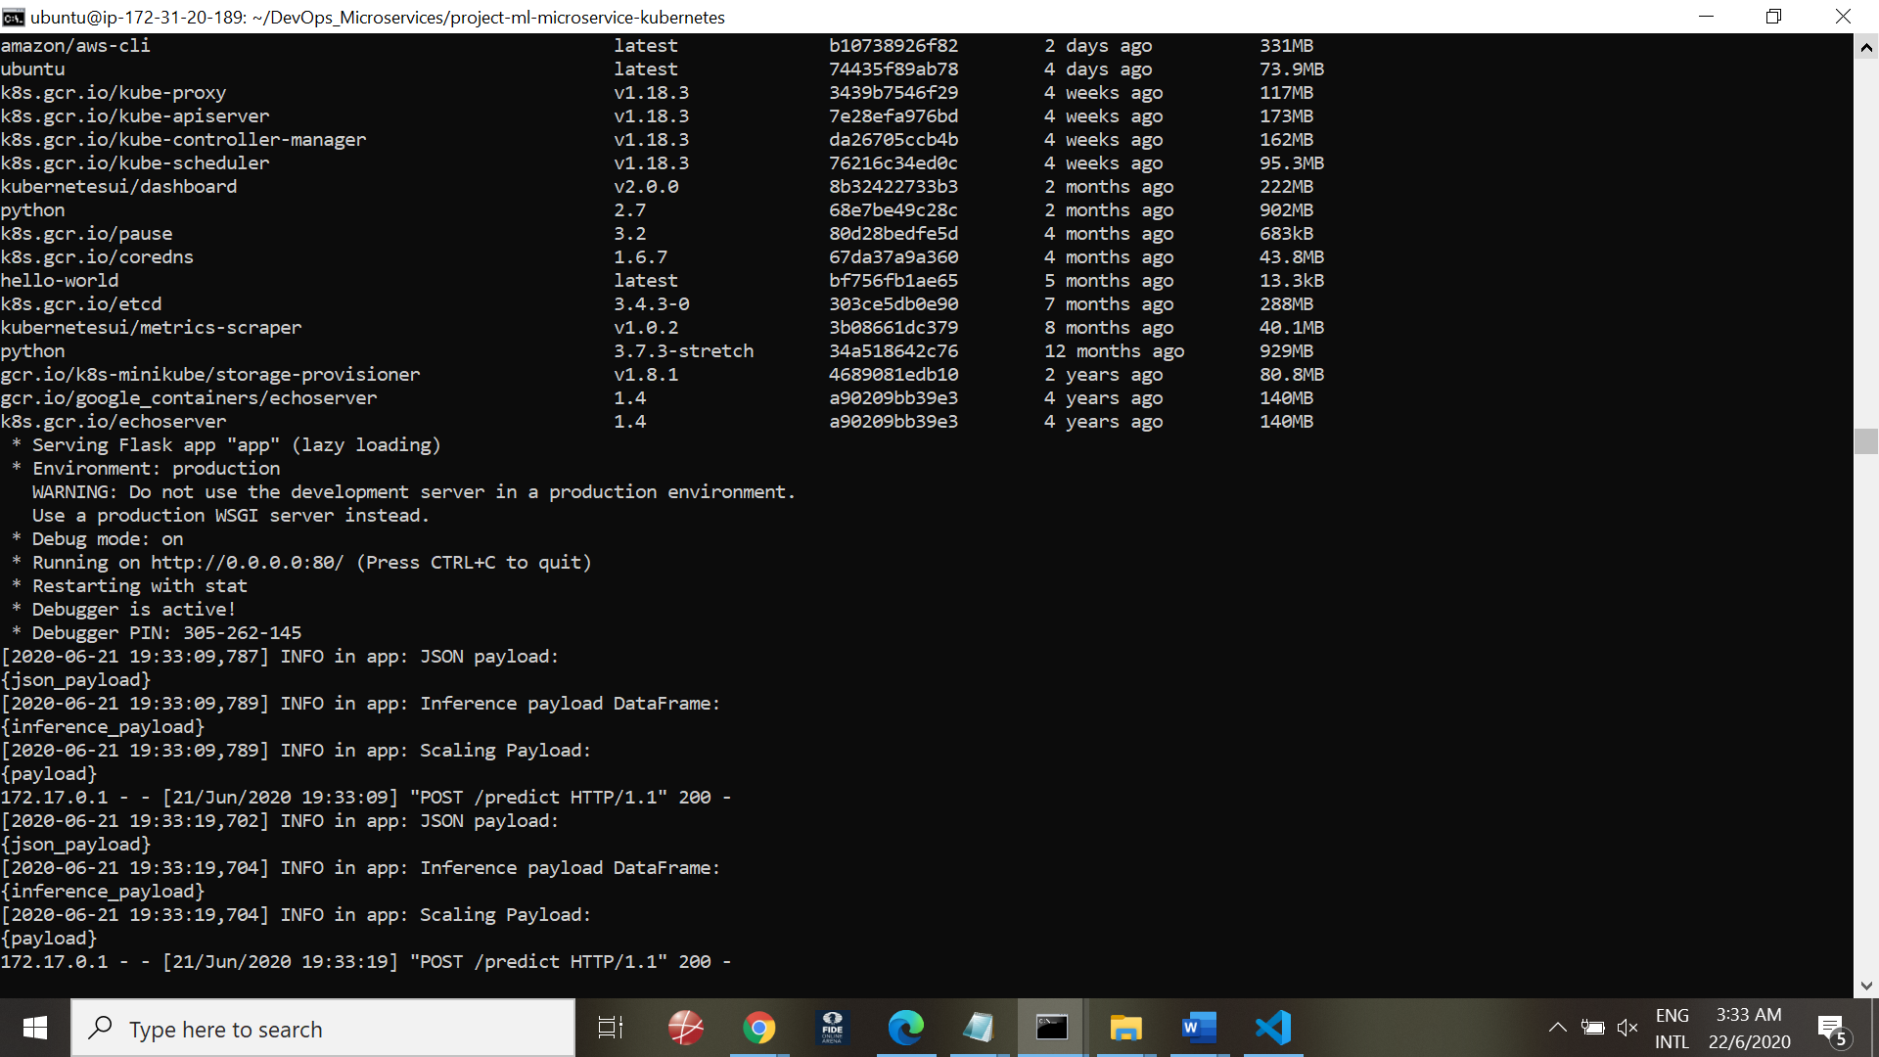

### Making predictions

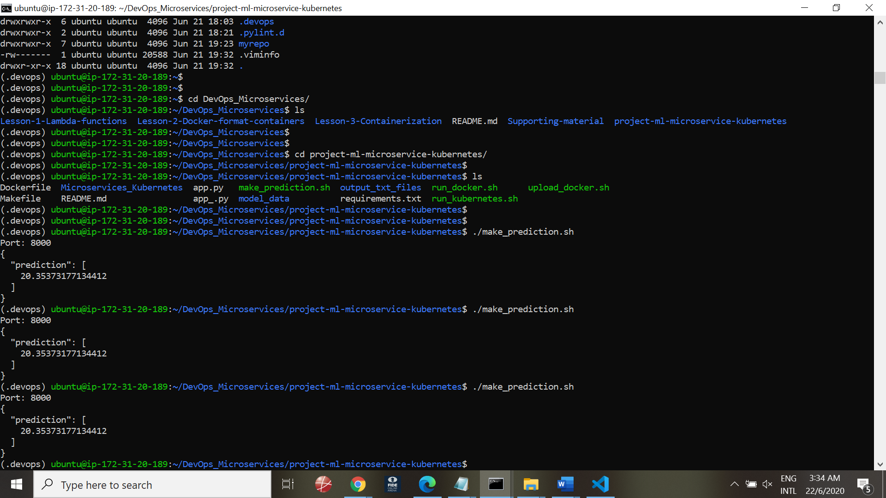

## Task 3: Improve Logging & Save Output

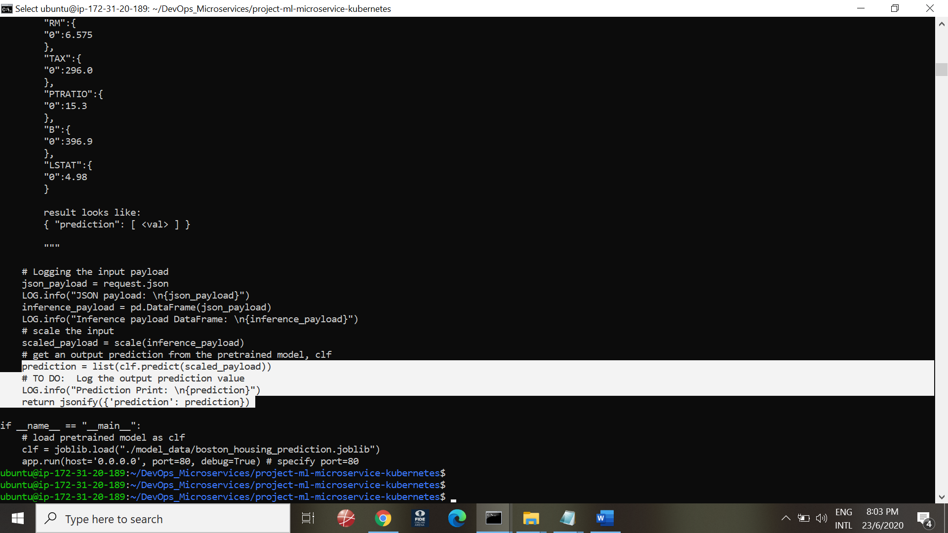

Run Docker script

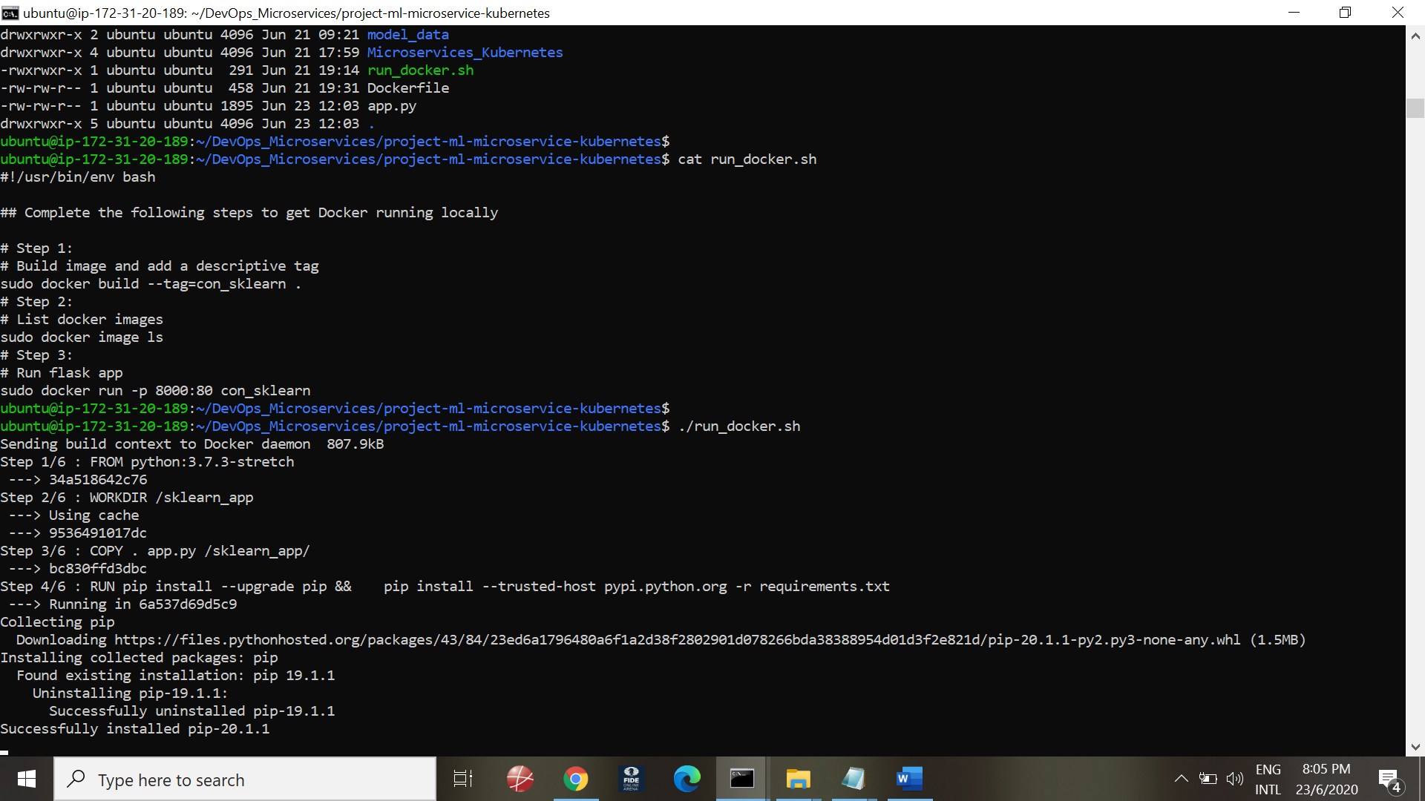

## Task 4: Upload the Docker Image

## Ready the script:

## 

## 

## Successful completion

## 

## Verification of repository n Docker Hub

## 

## Task 5: Configure Kubernetes to Run Locally

## 

## Kubectl config view

## 

## Task 6: Deploy with Kubernetes and Save Output Logs

## 

## Describe POD:

## 

## Port forwarding:

## kubectl port-forward podsklearn 8000:80

## 

## Running curl command on localhost:8000

## 

## Task 7: [Important] Delete Cluster

## Minikube stop

## 

## Task 8: CircleCI Integration

## Login to CircleCI

## 

## 

## Choose Microservices_Kubernetes project and choose Setup Project.

## 

## Successful execution

## 

## 

END